Fish eyed captcha
About
The dataset can be found from this url https://figshare.com/articles/Fish_ Eye/12235946 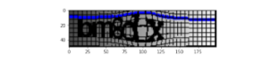
My understanding
We can see there is a lot of variety in this type of CAPTCHA. This type of CAPTCHA poses a real challenge to machine learning systems.
There is grid, a line and bold letters which is occluded by lines of different colors. The deep learning model needs to learn each of the representation of the CAPTCHA dataset.
Frequency of the letters
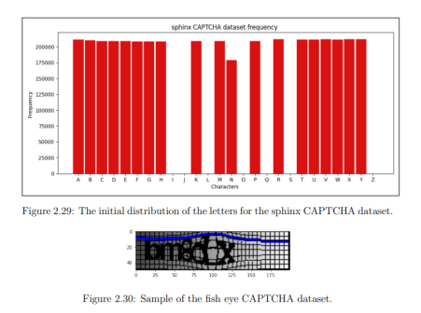It took about 3902 second per epochs and there was a total of 5 epochs The accuracy obtained on training’s validation set was about 94.49 % and the same for test dataset was 91.46 % which was pretty great given that the model converges in only 5 epochs.
Our model
